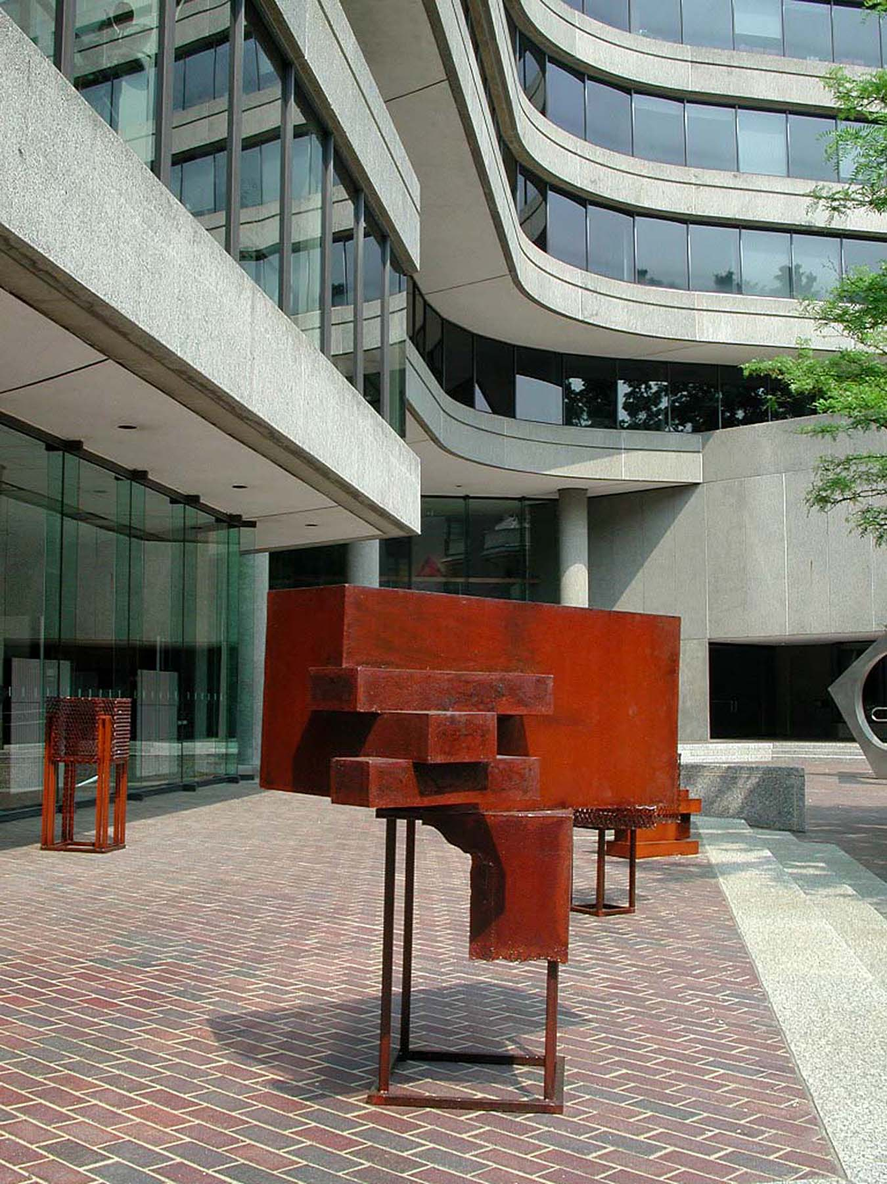

Architecture:
A Sculptor’s Perspective

The Museum of the
American Architectural Foundation

May 10 – June 30, 2001.

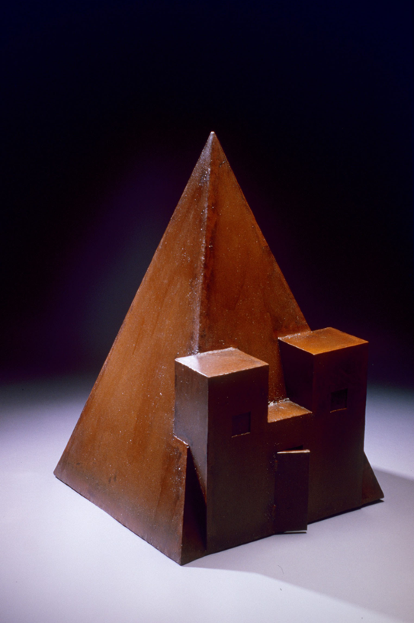

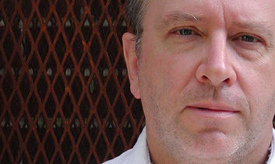
John B. Mors has been making sculpture for over 30 years. He graduated from the architecture school of the University of Sydney, Australia, in 1974, and subsequently studied sculpture at the Tom Bass School of Sculpture and at East Sydney Technical College. He relocated to the USA in 1985, where he studied at the Corcoran School of Art. In 1990, he received the degree of MFA from George Washington University, Washington, DC.
The subject of John's sculpture is architecture and religious art. He is especially interested in primitive art and the levels of knowledge associated with rites of passage. As a result of this interest, he has traveled in Europe, Africa, the Pacific, and the USA.

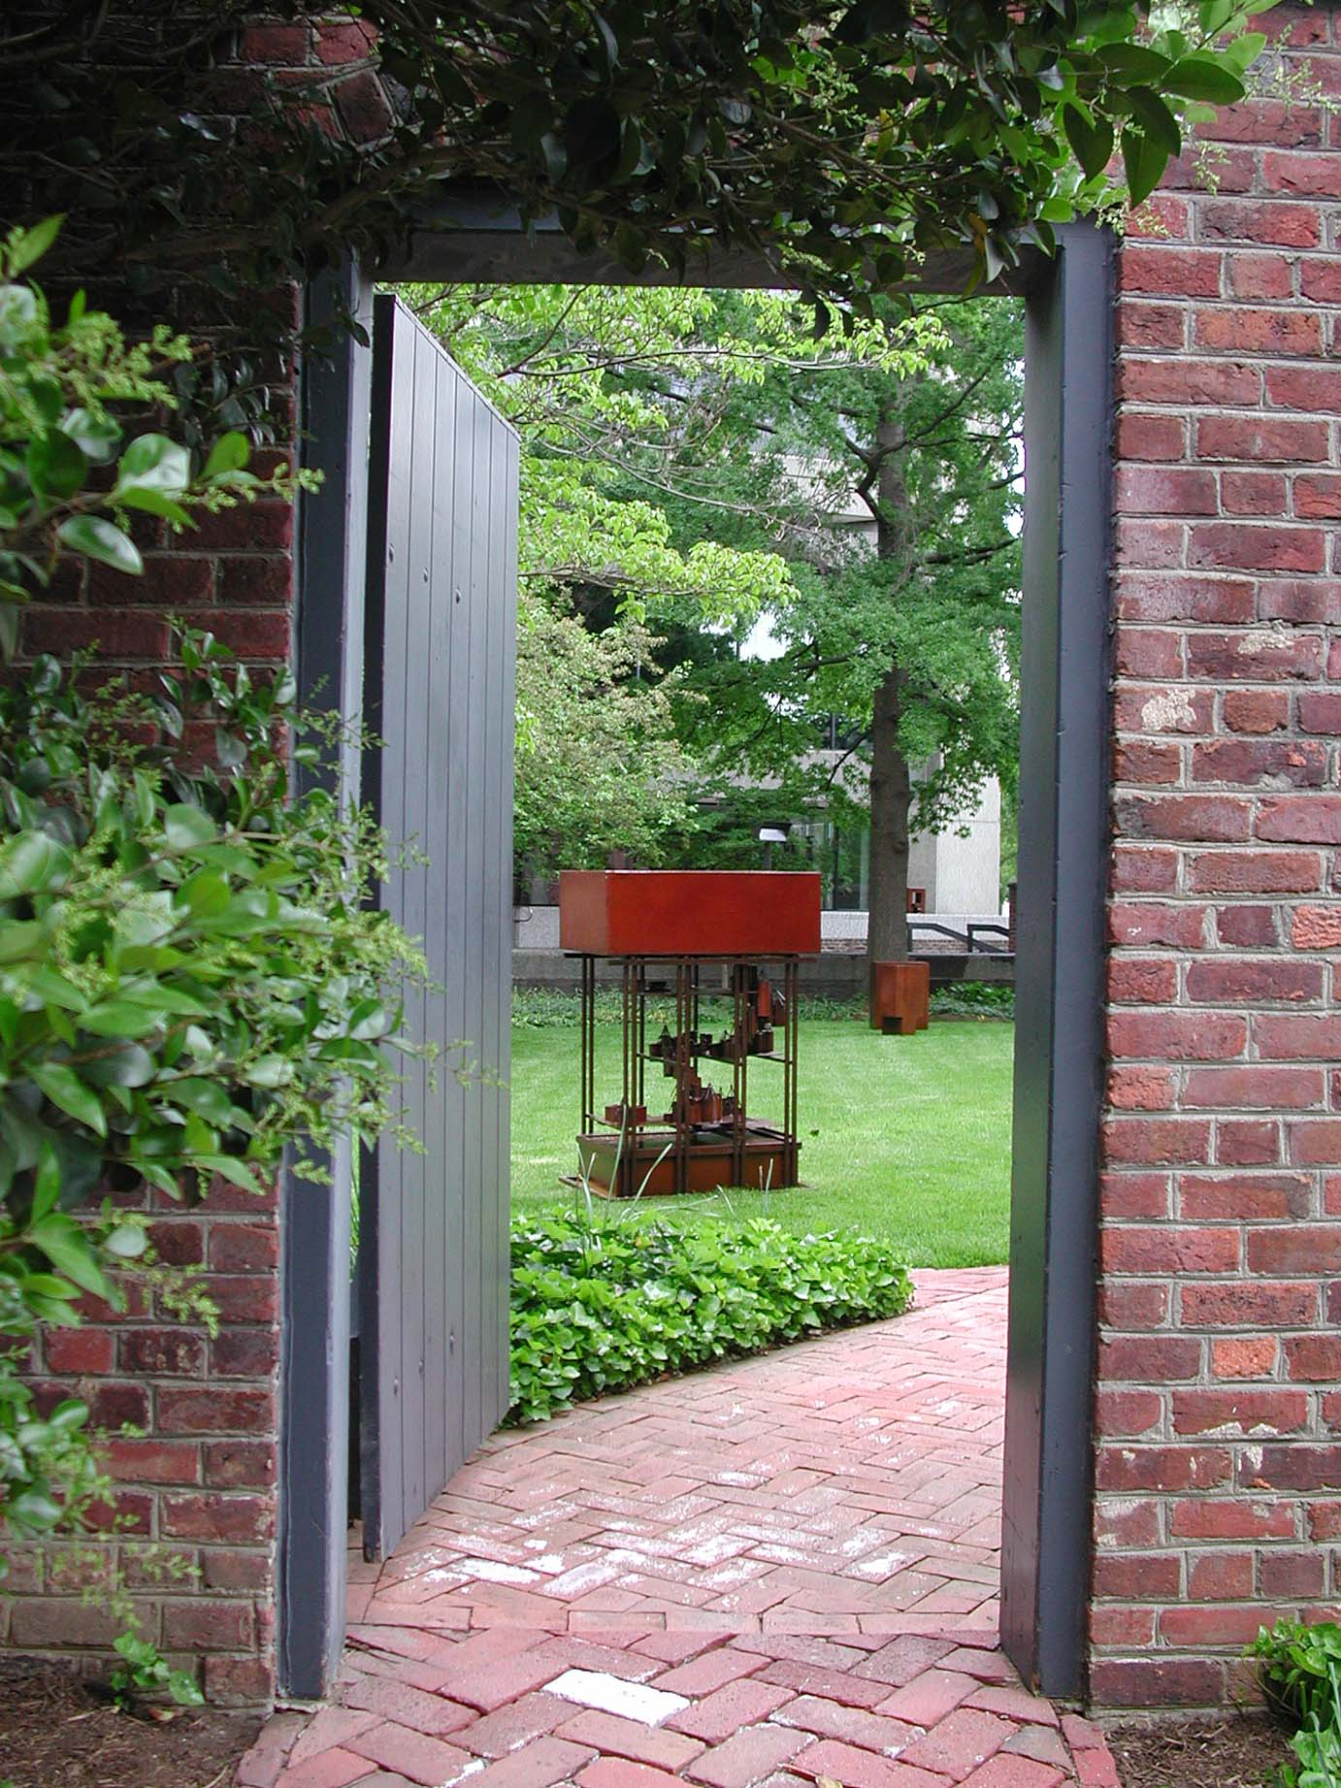

JOHN MORS | 

Personal
 | Born 1951, Sydney, Australia.
 | U.S. Residency ("Green Card'"). 1988.
 | Dual Australian and U.S.A. Citizenship. 2002.
Formal Education
1990 | M.F.A. Sculpture, (4.0/4.0 GPA),
 |  | George Washington University, Washington, D.C.
 |  |  | David Lloyd Kreeger Prize in Sculpture (1989,1990).
 |  |  | Alfred E. Steck Memorial Prize in Sculpture.
 |  |  | University Fellowship.
 |  |  | Graduate Teaching Assistantship.
1987 | Corcoran School of Art, Washington, D.C.
1986 | The Art League School, Alexandria, Virginia.
1980 | Stanley Street School of Art and Craft, Adelaide, Australia.
 | East Sydney Technical College, (formerly National Art School), Sydney, Australia.
1978 | Oxy-acetylene Welding course, Sydney, Australia.
1974-5 | Tom Bass School of Sculpture, Sydney, Australia.
1974 | BS (Architecture), The University of Sydney, Sydney, Australia.
Selected Exhibitions
2008 | Solo Exhibition, Mansion Art Gallery of Rockville, Rockville, MD.
 | Exhibited "Sculpture on the Grounds," Rockville, Maryland.
2006 | 25th Annual Montpelier Invitational Sculpture Exhibition, Montpelier Arts Center, Laurel, MD.
2001 - 2006 | The Residence of the Australian Ambassador, Washington, DC.
2002 - 2003 | The Embassy of Australia, Washington, DC.
2001 | The American Institute of Architects / Octagon Museum, Washington, DC.
 | Summer Salon 2001, Ellipse Art Center, Arlington, VA.
 | Decorators' Show House at "White Oaks", Washington, DC.
 | Inclusion of sculpture image in Visibooks 'Fireworks 4 for Visual Learners'.
2000 | Mansion Art Gallery of Rockville, Rockville, Maryland.
 | Exhibited "Snapshot", Contemporary Museum, Baltimore, MD.
 | Creative Visions Television Invitational, Gallery West, Alexandria, VA.
 | Exhibited "Sculpture on the Grounds," Rockville, Maryland.
 | Exhibited "Year 2000, Around the Garden Sculpture Show," Brookside Gardens, Maryland.
1999 | Exhibited "Sculpture '99," Towson University, Maryland.
 | Exhibited "Art in Landscape," The Lillian Holt Center for the Arts, Maryland.
 | Exhibited "Sculpture in the Grounds," Rockville, Maryland.
 | Exhibited "Sculpture Now. '99," Washington, DC.
1997 | Exhibited efformSublime, ArtScene Gallery, The National Press Building, Washington, DC.
 | Exhibited ArtScene at The National Press Building, Washington, DC.
1996 | Four Person Exhibition, Cardinal Gallery,
 |  | Maryland Hall for the Creative Arts, Annapolis, Maryland.
1995 | Exhibited "Sculpture Now. '95," Washington Square Art Program, Washington, DC.
1994 | Exhibited "Across Borders/Sin Fronteras," The Art Museum of the Americas,
 |  | Organization of American States, Washington, DC.
1992 | Exhibited at Universal North building, Washington, DC.
 | Exhibited "Totems," The Art Barn, Washington, DC.
1991 | Solo Exhibition, Cardinal Gallery,
 |  | Maryland Hall for the Creative Arts, Annapolis, Maryland.
 | Exhibited "Found Objects," Delaware Center for Contemporary Art, Wilmington, Delaware.
 | Exhibited "Art about Function," Washington, DC.
 | Exhibited "MFA Show," Dimock Gallery, George Washington University, Washington, DC.
1985 | Solo Exhibition, Irving Sculpture Gallery, Sydney, Australia.
1982 | Solo Exhibition, Irving Sculpture Gallery, Sydney, Australia.
1981 | Exhibited "First Australian Sculpture Triennial," Melbourne, Australia.
Non-Formal Education (Travel)
2006 | Australian Aboriginal art sites in the Sydney region.
1999 | Italy to study Roman and Etruscan art (Rome, Pompeii, Tarquinia and Cerveteri).
1996 | Italy to study Italian religious art (Florence and Venice).
1995 | Italy to study Italian religious art (Florence, Venice and Rome).
1993 | France (Paris, Brittany (religious calvaries and megaliths), Dordogne (cave paintings)).
 | Mali, West Africa, with The Center for African Art, New York.
1992 | South-west Indian archaeological sites and reservations.
1991 | Australian Aboriginal art sites in the Sydney region.
 | France to study French religious sculpture.
1987 | Ohio Indian sites (funerary and figurative mounds).
1986 | South-west Indian archaeological sites.
 | France.
1985 | Relocated to U.S.A.
1982 | New Guinea (Highlands and Sepik River).
1978 | Australian Aboriginal art sites (Northern Territory, Adelaide, and Perth).
1976 | Western Europe (especially France and Spain).

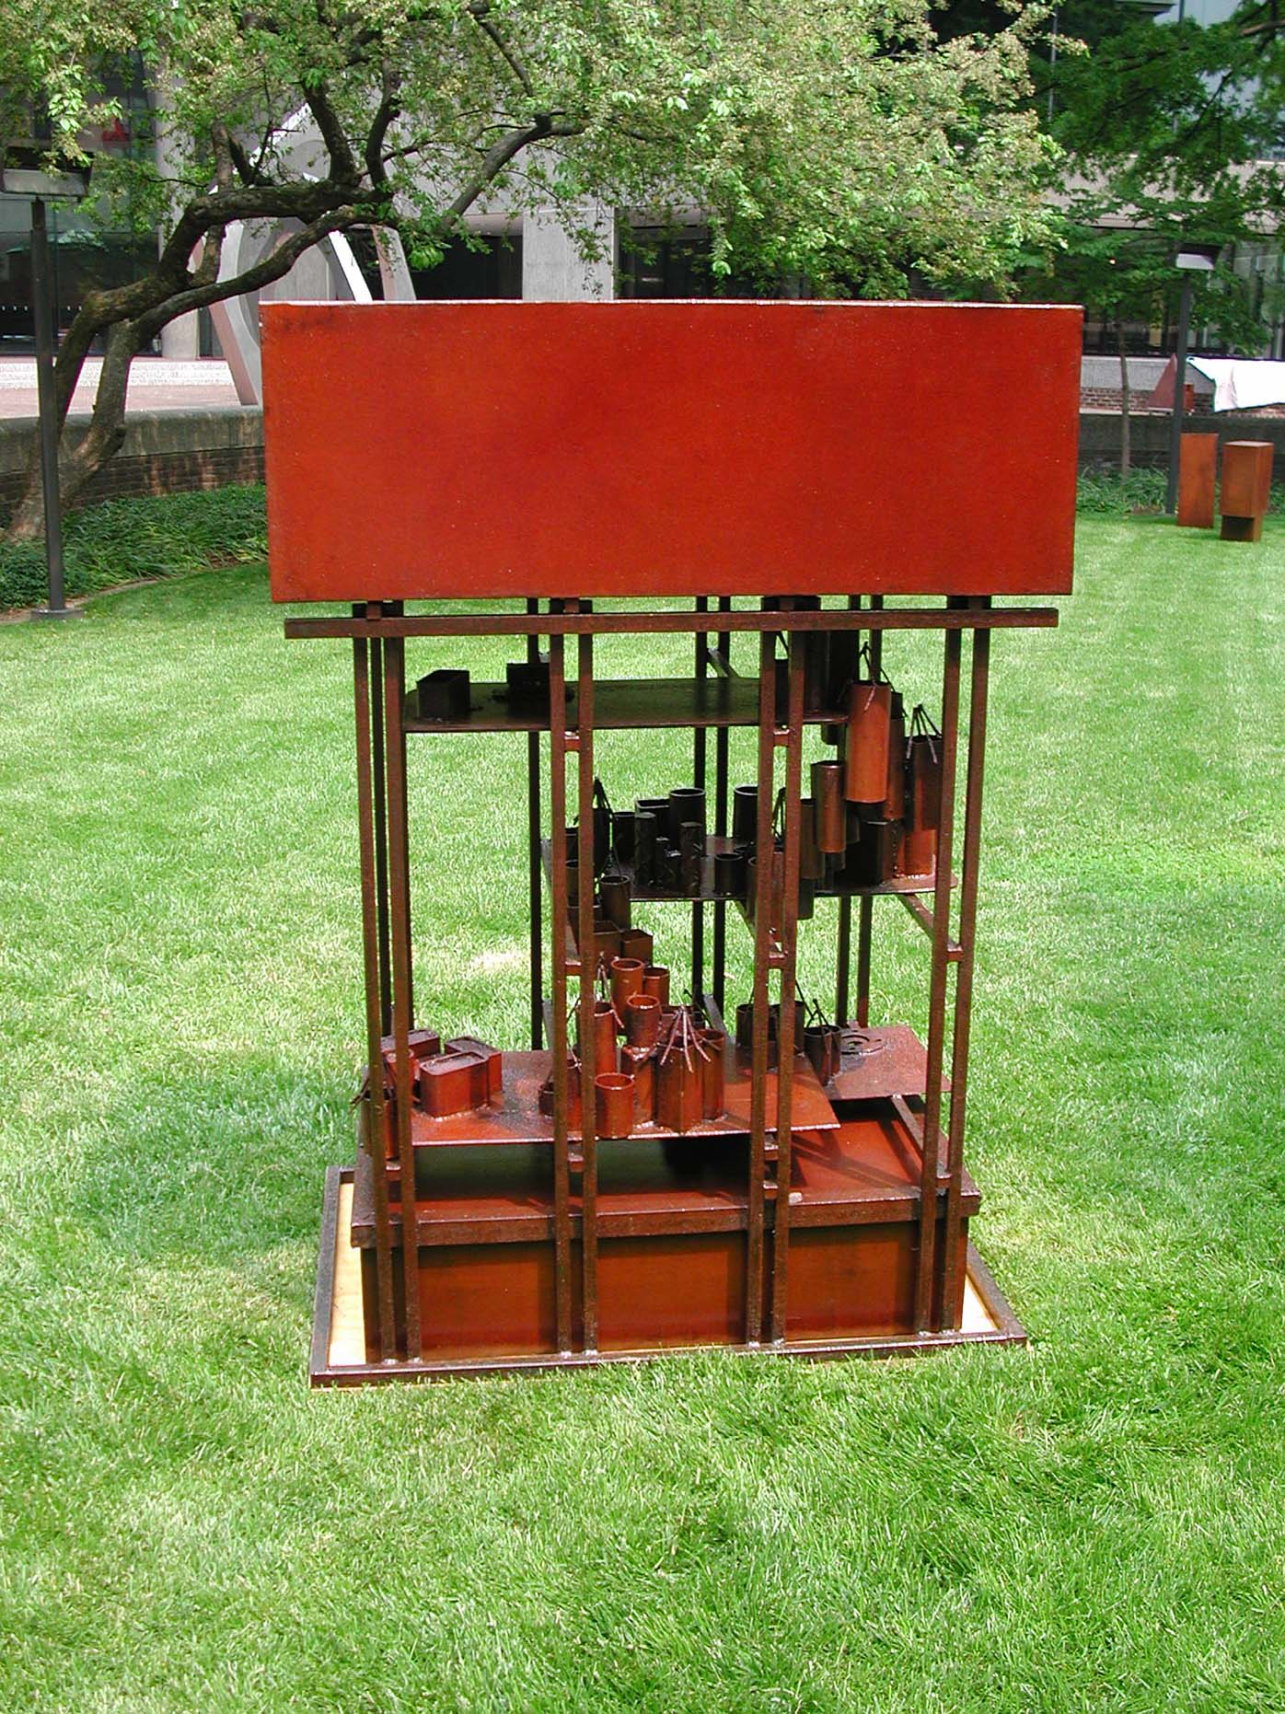

ARTIST'S STATEMENT
John B. Mors

Making sculpture based on house forms is a natural approach to art for me. Although I have never worked as an architect, my training in the profession defines the way I structure knowledge and perceive the world. Producing art based on architecture combines my knowledge of structural engineering, anthropology, and art, and a love of materials.  Therefore, my basic philosophy is that: | 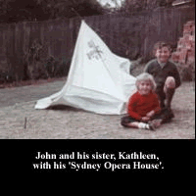

Art Must Be More Than Purely Visual
Because art must be more than purely visible, my work addresses the following issues:
- The Hidden Meaning of Architecture
- The Subject / Object Dichotomy
- Art as a Process of Making
- Levels of Knowledge
Suggested reference books are listed at the end of the page.
The Hidden Meaning of Architecture
Architecture is more than just a place of habitation. Architecture is the manifestation of a culture's creation myth and worldview.
The early house forms of the Anasazi of the American southwest are referred to as pit houses. These were houses that were half dug into the ground.
Over time, the houses were built more on the surface of the ground, culminating in the cliff houses typically found at Mesa Verde and Chaco Canyon. At the same time as the habitation houses were emerging from the ground, the form of the Kiva, the ceremonial house consisting of a cylindrical chamber dug into the earth with an entrance in the center of the roof, was evolving.
Therefore, the original pit house form evolved into two distinct forms: an inhabited cliff house, and a ceremonial Kiva. Thus the Kiva, as an evolution of the pit house, is more than a dwelling; it reflects the origins of the Anasazi culture.
Similarly, Dogon men meet beneath a structure called a Togu Na. This is a structure consisting of a series of external columns, covered with a roof of maize stalks. This reflects the origin myth of the Dogon, whose forebears rested beneath a cattle-feeding manger of the same form. Thus, the Togu Na reflects and therefore reinforces the origin of the culture.
The Subject / Object Dichotomy
Inherent in sculpture is the issue of object vs. subject. As a manufactured item, a sculpture is first and foremost an object because it occupied space. But sculptures are invariably about something. This something is their subject, which sets the frame of reference and the context. The issue of sculpture is the uneasy fight for dominance of object or subject.
The work of Richard Serra represents object. His sculpture exists as object; it is self-referential. The sculpture of Degas represents the opposite pole. Degas's sculpture exists as a reference to something, i.e. the subject.
In my work, I play with this dichotomy of the existence of sculpture. I aim to produce sculpture that is subject but which on closer inspection is object, and vice versa. That is the reason for my choice of steel as a medium, for it has no inherent or assumed subject.
Interestingly, it is people unfamiliar with art, and especially children, who see both the subject and the object in my work. Children still possess that sense of imagined potential when they observe something. For a child, a box can be a car, or a boat, and yet it still remains a box. They do not have the conflict of perception that we adults possess.
Art as a Process of Making
I believe that the interaction between the artist and the material is an essential part of the development of the object.
My education in architecture stressed a strong separation between the intellectual act of design and the physical act of fabrication. This codifies a class distinction that I cannot accept. For me, the great joy of sculpture is the actual making of art, for I find the physicality of my material very satisfying.
All of my work is welded using an electric welder. Other types of welders would give a better finish, but these methods lack the rough physically, and remove the 'sense of hand'. Likewise, steel is a material that has no noble pretensions, and the act of fabricating steel is first and foremost labor. However, I do accept the irony of the situation. I fabricate steel as a luxury. Any person who welds steel for a living would not possess such a romantic view of the material.
Levels of Knowledge
In a small-scale culture, a child knows that a mask is actually the spirit that it represents. At each stage of initiation into manhood, progressively more knowledge is gained about the object. However, it never becomes purely a mask, not even to the maker.
My sculptures are derived from this concept of levels of knowledge. Initially, the sculptures may appear as abstract forms. To someone familiar with the subject matter, the forms are known. The person aware of the subject matter (often identified by the title) may think that they know the significance. However, as always, it is only the maker of the object who knows the truth or otherwise of the piece. For it is they who know what is revealed and what is withheld.
References
Andrews, Lew. Story & Space in Renaissance Art: The Rebirth of Continuous Narrative. Cambridge University Press. September 1998. ISBN: 0521646634
Dewey, John. Art As Experience. Berkley Publishing Group. March 1959. ISBN: 0399500251
Humphrey, Caroline and Vitebsky, Piers. Sacred Architecture. Little Brown, 1997. ISBN: 0316381225
McNaughton, Patrick, R. The Mande Blacksmith : Knowledge, Power and Art in West Africa. Indiana Univ Pr. April 1998. ISBN: 025333683
Rapoport, Amos. House Form & Culture. Prentice Hall. February 1969. ISBN: 0133956733
Tucker, William. Language of Sculpture. Thames & Hudson. September 1985. ISBN: 0500271046
Tufte, Edward R. Visual Explanations : Images and Quantities, Evidence and Narrative. Graphics Press. January 1997. ISBN: 0961392126

AIA Sculpture List
All sizes are Height by Length by Width.

Australasian Images
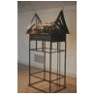 | House Tambaran, Sepik River, New Guinea.  Steel.1989.  86" x 43" x 36".
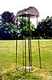 | Wet Season Hut, North-eastern Arnhem Land, Australia.  Steel.1991.  84" x 27" x 27".

Anasazi Details Series
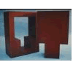 | Keyhole Window - Positive Form.  --- Keyhole Window - Negative Form.  Steel.1992.  38" x 28" x 14". and 38" x 24" x 12".
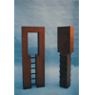 | Keyhole Door - Positive Form.  --- Keyhole Door - Negative Form.  Steel.1992.  44" x 16" x 7". and 44" x 10" x 6".
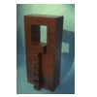 | Anasazi Grand Kiva Door - Positive/Negative Form.  Steel.1992.  40" x 18" x 14".

African Images
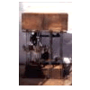 | A Walk in a Dogon Village.  Steel.1997/1998.  60" x 40" x 30".
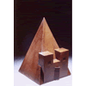 | Pyramid, Meroe, Sudan.  Steel.1999.  36" x 26" x 24".
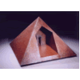 | Pyramid Inversion, Old Kingdom, Egypt.  Steel.1999.  24" x 38" x 38".

Memories of Times Past
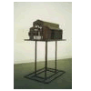 | Romanesque - Internal - Rome, Italy.  Steel.1998.  54" x 40" x 27".
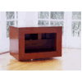 | Bench, Anasazi.  Steel.2000.  20" x 30" x 20".

The Wright Stuff
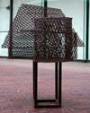 | Frank Lloyd Home and Studio, Oak Park, Chicago, Illinois.  Steel.2000.  21" x 32" x 30"
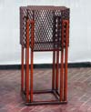 | Unity Temple, Oak Park, Chicago, Illinois.  Steel.2000.  41" x 20" x 20"
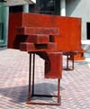 | Fallingwater ( Kaufmann House ), Mill Run, Pennsylvania.  Steel.2000  53" x 53" x 28"
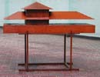 | Prairie House, Illinois.  Steel.2000.  36" x 48" x 20"
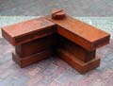 | Usonian House, Pope-Leighey Home, Alexandria, Virginia.  Steel.2000.  19" x 30" x 30"

